1. **Project Title: Academic Management System (using SQL):**

**1. Database Creation:**

a) Create the StudentInfo table with columns STU_ ID, STU_NAME, DOB, PHONE_NO, EMAIL_ID, ADDRESS.

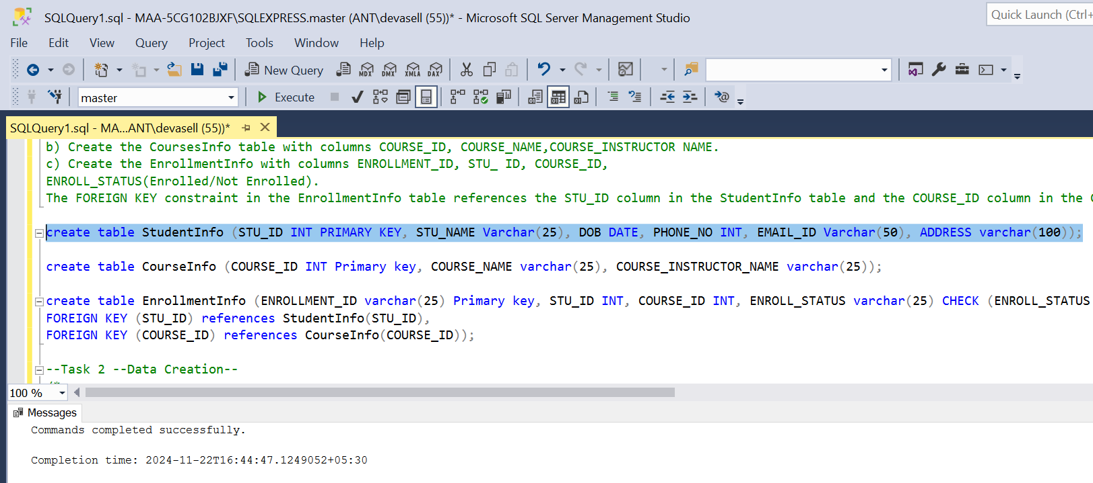

b) Create the CoursesInfo table with columns COURSE_ID, COURSE_NAME, COURSE_INSTRUCTOR NAME.

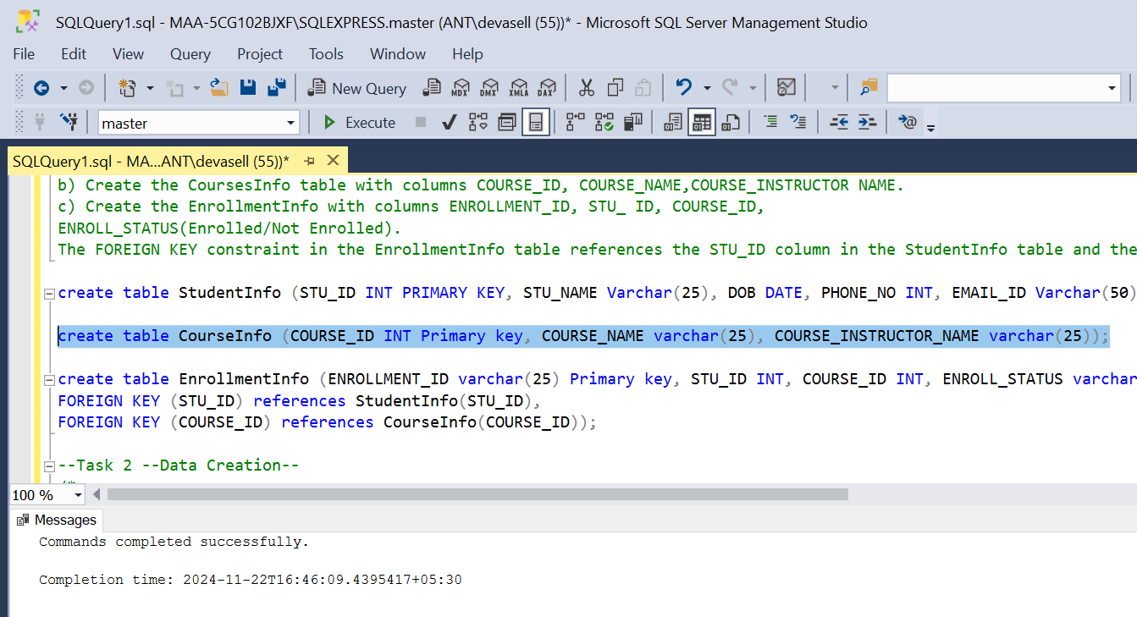

c) Create the EnrollmentInfo with columns ENROLLMENT_ID, STU_ ID, COURSE_ID, ENROLL_STATUS (Enrolled/Not Enrolled). The FOREIGN KEY constraint in the EnrollmentInfo table references the STU_ID column in the StudentInfo table and the COURSE_ID column in the CoursesInfo table.

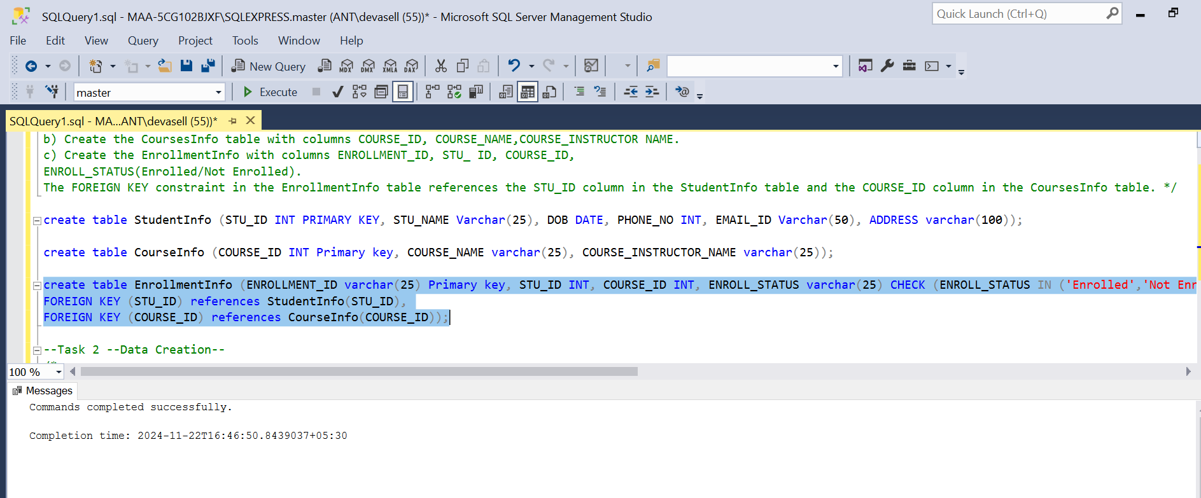

**2. Data Creation:**

Insert some sample data for StudentInfo table, CoursesInfo table, EnrollmentInfo with respective fields.

**StudentInfo table**

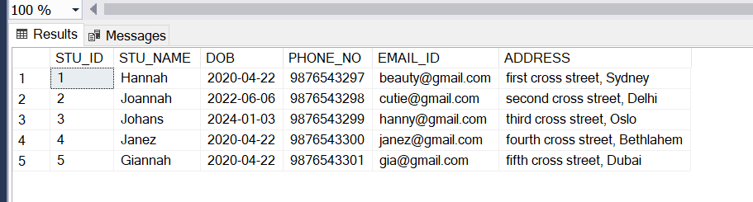

**CoursesInfo**

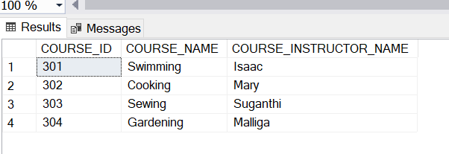

**EnrollmentInfo**

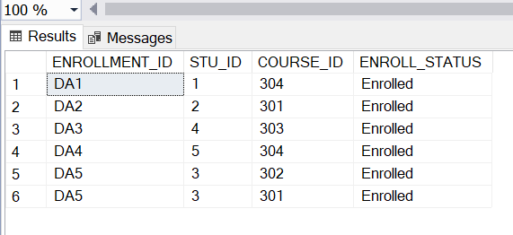

**3) Retrieve the Student Information**

a) Write a query to retrieve student details, such as student name, contact information, and Enrollment status.

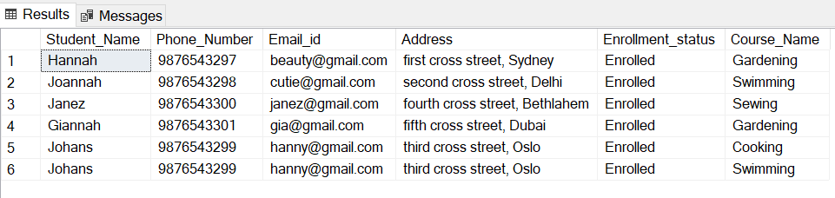

b) Write a query to retrieve a list of courses in which a specific student is enrolled.

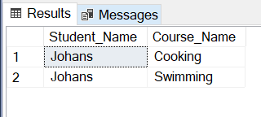

c) Write a query to retrieve course information, including course name, instructor information.

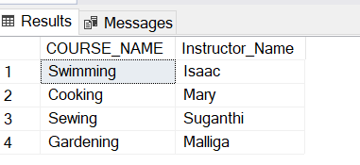

d) Write a query to retrieve course information for a specific course.

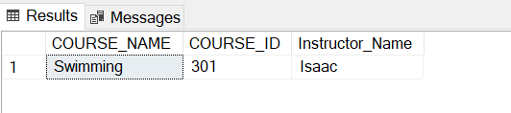

e) Write a query to retrieve course information for multiple courses.

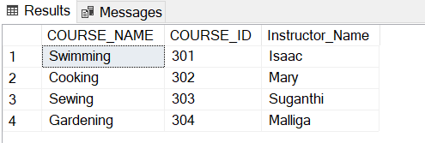

f) Test the queries to ensure accurate retrieval of student information. ( execute the queries and verify the results against the expected output.)

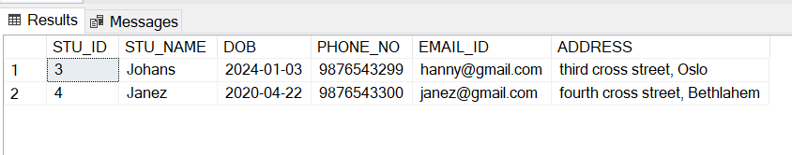

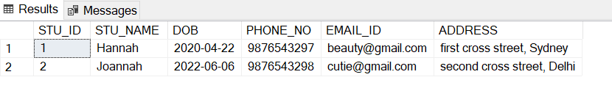

**4. Reporting and Analytics (Using joining queries)**

1. Write a query to retrieve the number of students enrolled in each course

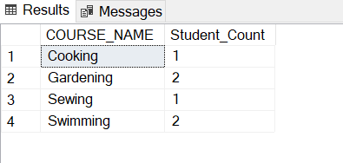

b) Write a query to retrieve the list of students enrolled in a specific course

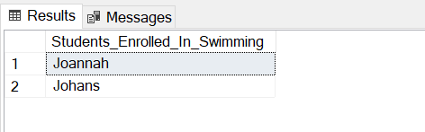

c) Write a query to retrieve the count of enrolled students for each instructor.

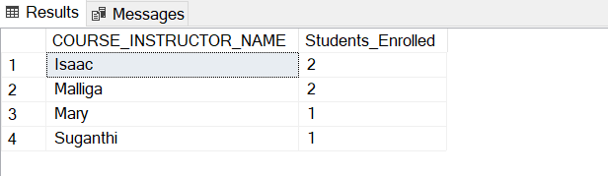

d) Write a query to retrieve the list of students who are enrolled in multiple courses

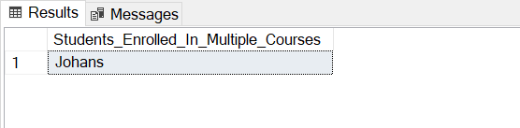

e) Write a query to retrieve the courses that have the highest number of enrolled students (arranging from highest to lowest)

